ESSENTIAL METRICS FOR CHATBOTS

Some key points for chatbot metrics::

* **Active rates and engaged rates**::Active implies user is online but has not responded,engaged implies user has responded.

Active rate : defined as no. of active sessions of a user/total number of sessions of that user.

Engaged rate;defined as no. of engaged sessions of that user/total number of sessions of that user.

* Average number of conversations per user.
* Time required by user for a response(Retention rate)
* Confusion rate
* Goal/Task completion rate
* **URL::**
* **1)**[**https://venturebeat.com/2016/10/04/5-metrics-every-chatbot- developer-needs-to-track/**](https://venturebeat.com/2016/10/04/5-metrics-every-chatbot-%20developer-needs-to-track/)
* **2)**[**https://appinventiv.com/blog/key-metrics-to-evaluate-your-chatbots-performance**](https://appinventiv.com/blog/key-metrics-to-evaluate-your-chatbots-performance)
* **3)**[**https://www.entrepreneur.com/article/295447**](https://www.entrepreneur.com/article/295447)

**(**10 metrics to optimize chatbots**)**

**USE OF AI in RECRUITMENT AUTOMATION**

3 components of Recruitment automation::

1)*Resume screening*::Powered by AI,intelligent screening software **uses employee data** on performance and tenure,the software figures out which candidates went on to become successful and unsuccessful candidates.

**Advantages::**

{a}Reduces time to hire because it automates a low value,repitive task that most recruiters hate to do anyway.

{b}allows recruiters to **focus their time** on high value priorities like talking to candidates to assess their personalities.

*2)Recruitment automation for pre-qualification*:: In form of chatbots,AI aids in improving candidate experience. 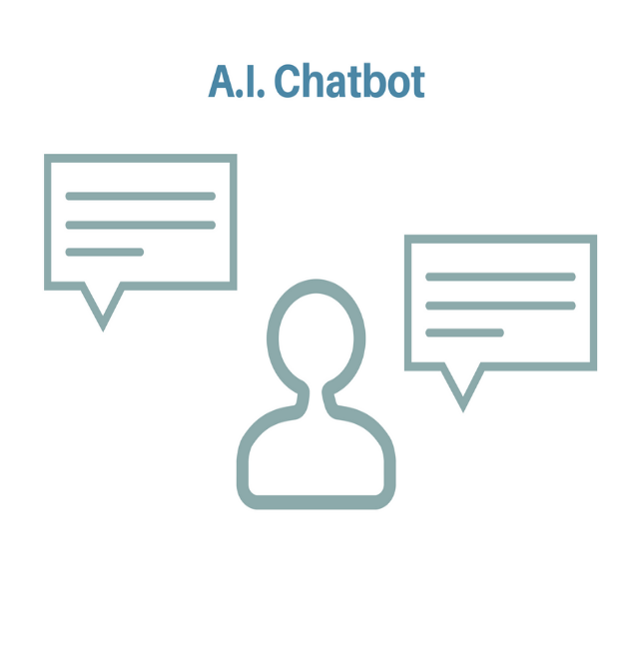

**Advantage::**

Allows human recruiters to provide these consistent updates in real time by asking pre-defined questions,related to job requirements and providing feedback updates and next step suggestions.

*3)For interviews::*

(*1)record candidate interviewing and

(*2)asses factors like ->word choices

->speech pattern

->facial expression

And judge if candidate fits the role or not.

We can also add additional data points

**URL::** <https://ideal.com/3-ways-recruitment-automation-will-change-recruiting-forever/>

<https://www.entelo.com/recruiting-automation/>

**The best automation tools for building recruitment softwares powered by AI::** <https://medium.com/@DDI_Development/the-6-best-recruiting-automation-tools-for-2018-fb50dd116cc6>

<https://ideal.com/recruiting-automation-tools/> (include chatbots)

Recruiting automation solutions are most commonly implemented in HR departments and are often integrated with [applicant tracking system (ATS) software](https://www.g2crowd.com/categories/applicant-tracking-system-ats) and [CRM software](https://www.g2crowd.com/categories/crm) to streamline the entire job hiring process from candidate sourcing through employee management.

**Comparative study of automation software::** <https://www.g2crowd.com/categories/recruiting-automation>